• **Inner Join**: Only matched rows are returned.

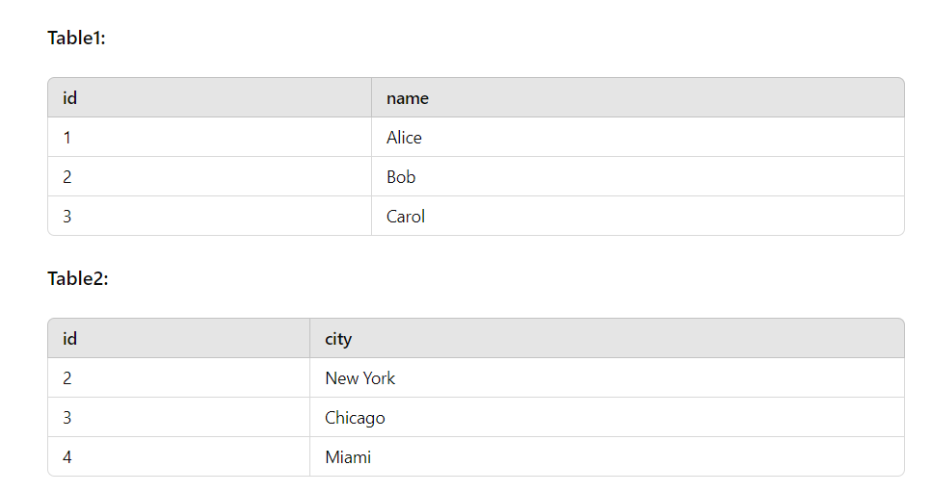

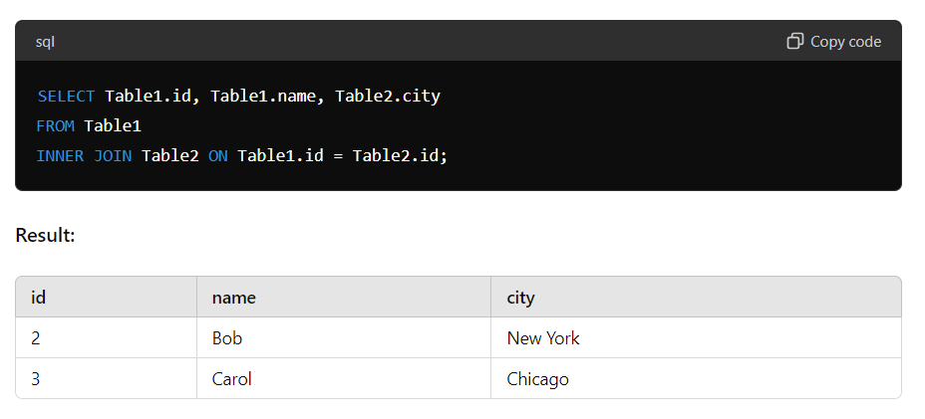

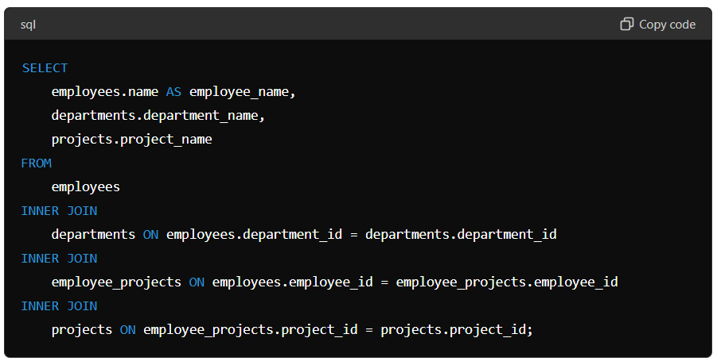

• **Left Join**: All rows from the left table and matched rows from the right table.

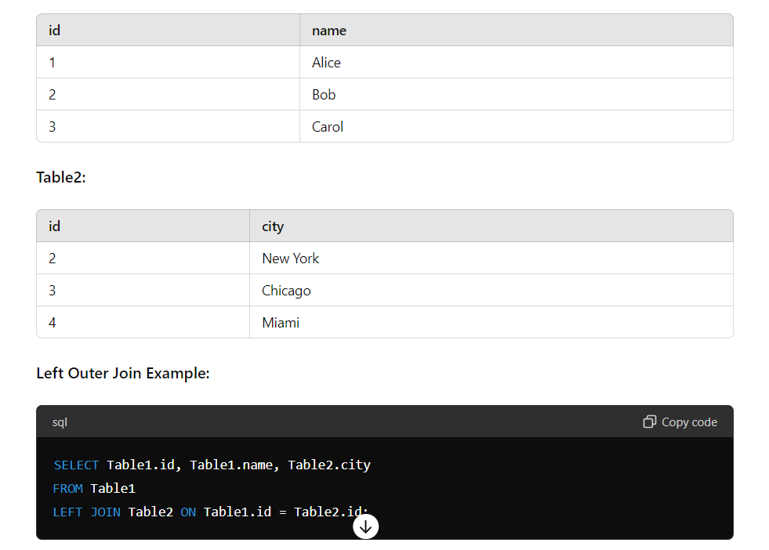

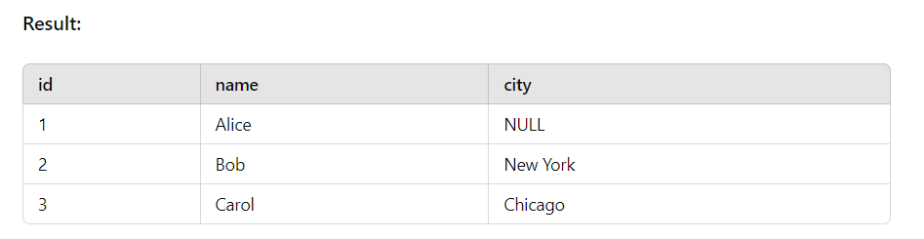

• **Right Join**: All rows from the right table and matched rows from the left table.

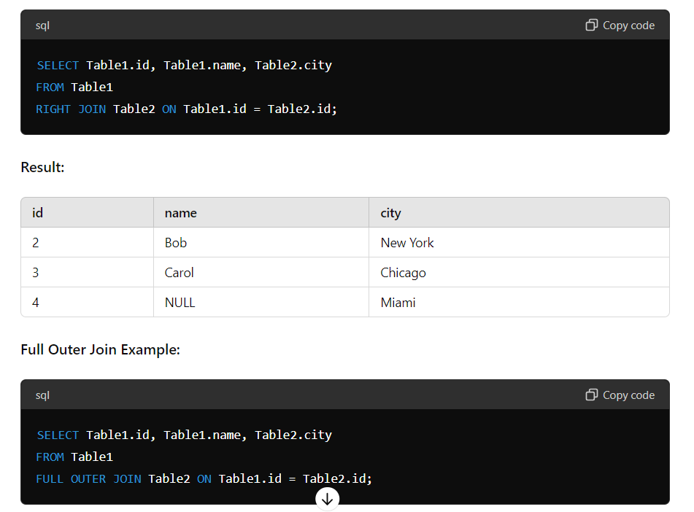

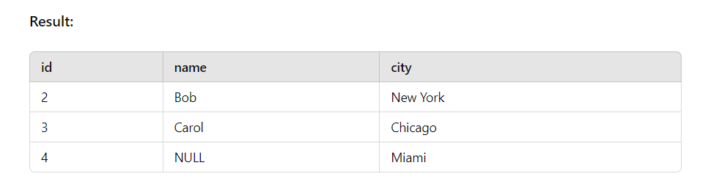

• **Full Join**: All rows when there is a match in either table.

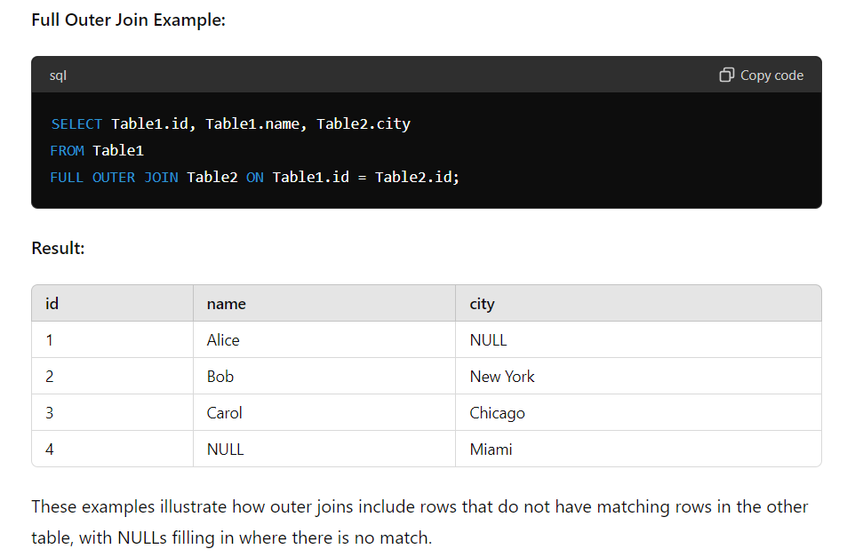

• **Cross Join**: Cartesian product of all rows from both tables.

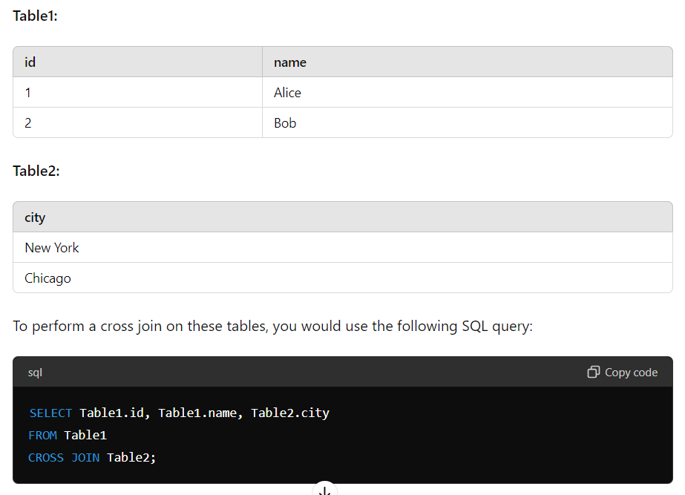

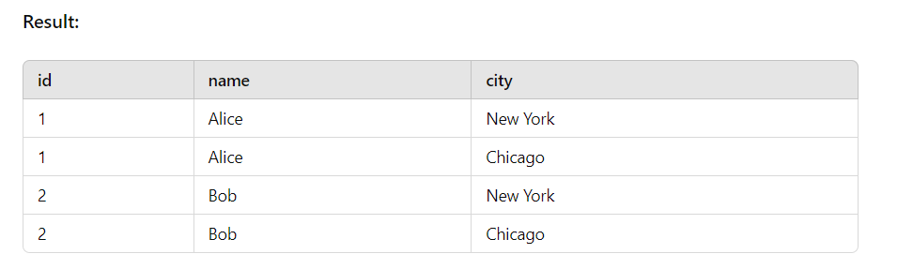

A cross join in SQL, also known as a Cartesian join, is a type of join that returns the Cartesian product of the two tables involved. This means it returns all possible combinations of rows from the two tables. Unlike other types of joins, a cross join does not require a condition to join the tables.

• **Self Join**: Joining a table with itself.

A self join in SQL is a join where a table is joined with itself. This is useful when you need to compare rows within the same table. A self join is typically implemented using table aliases to differentiate the instances of the table involved in the join.

